


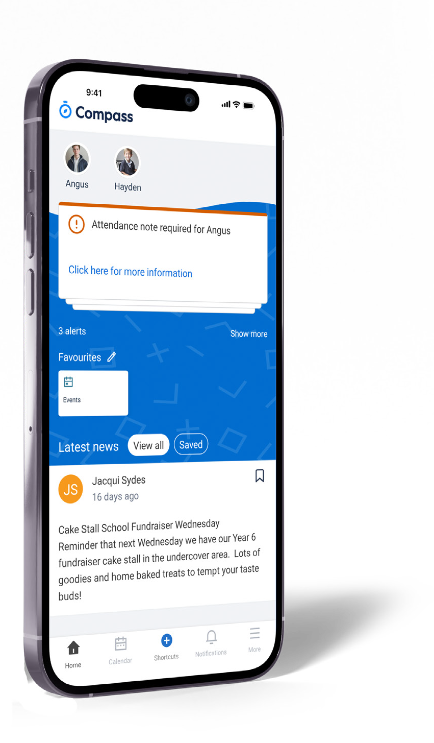
How to access Compass

Download the ‘Compass School Manager’ app for iOS and Android from your app store for mobile devices.
Enter ‘schools.compass.education’ in a web browser for desktop computers.
To login to Compass use the username and temporary password provided by your school.


The Kaartdijin Solution
for parents/guardians
Connect to your school’s Compass portal and stay updated with your child’s progress and important school news.

STUDENT ABSENCES
Advise of absence using ‘Attendance Notes’.

Parents will get this SMS with the link if their
child is marked absent without an explanation.
Parents should use this link to add attendance
notes about their child’s absence. Please note
that the link will be valid for only 48 hours.
Do not reply to this message via SMS as
the school will not receive it. The school will
receive your response via the link provided.
Ensure the phone is connected to an Internet
data plan or has WIFI access for the hyperlink.

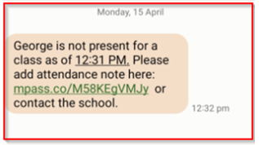

If the child is absent again without a prior
explanation, parents will get a new one-time
link. If parents do not use the link provided,
they can notify the school of their child’s
absence via Connect or email -
bibralake.ps.reception@education.wa.edu.au

What’s in the Compass parent portal?


Your child’s profile
- View attendance and behaviour/ wellbeing records
- Email your child’s teachers
- Submit absent or late notes

The Kaartdijin Solution for schools uses Compass, an online school management system, to manage student attendance and wellbeing and communicate important school information.
The Kaartdijin Solution for parents/guardians allows schools to invite parents/guardians to connect with them online through their Compass parent portal.

Important reminders
- For attendance notes
- Consent for excursions

Latest school news
- Receive news updates relevant to you, such as newsletters or details of upcoming events

Calendar

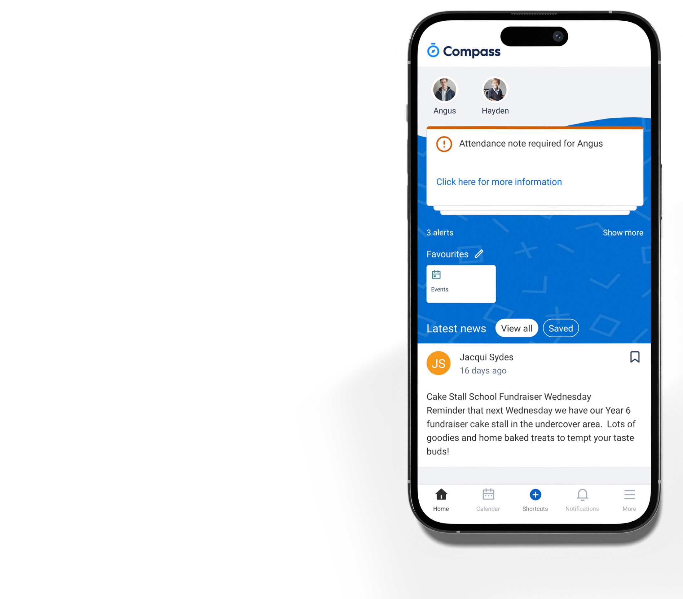

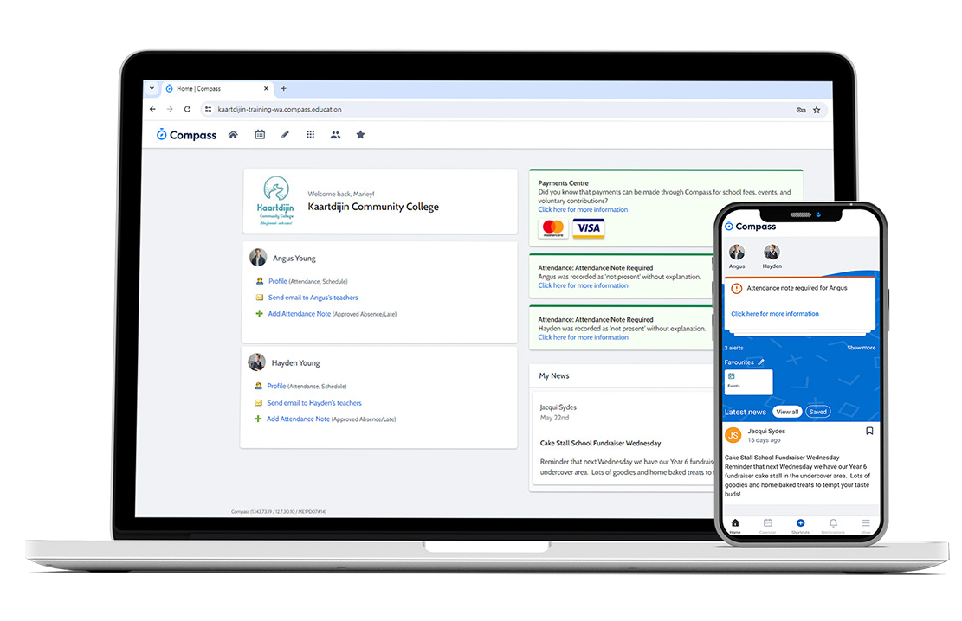
  - View your child’s upcoming excursions and school events

