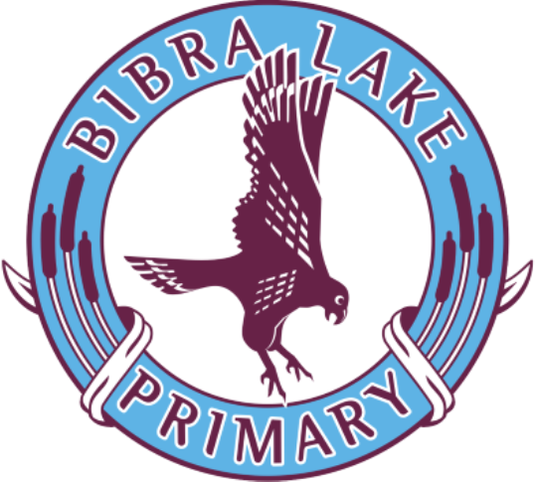
Bibra Lake Primary Whole School Approach to Behaviour

Board Endorsed: 10 August 2023 to be reviewed: 2027
2025
CONTENTS

Rationale 2
Purpose and Intent 2
Vision and Values 2
Response to Intervention 3

Tier 1 – A Positive Whole School Approach 4
Creating a Positive School Culture 4
Positive Student Incentives 4
Code of Conduct 5
Rights and Responsibilities 5
Social Emotional Learning (SEL) Curriculum 6
Restorative practice 7
Behaviour Management Procedures 7
Classroom Procedures for Years PP-6 7
Playground Procedures 8
Duty Teacher 9
Severe Behaviours 9

Tier 2 – Targeted Intervention 10

Tier 3 – Individualised Intensive Intervention 11
Case Management 11
Students at Educational Risk 11
Behaviour Management Plans 11
Regaining Good Standing 12
Non-Suicidal Self Injury (NSSI) 12

Appendix A – Behaviour Management Process Chart 13

Appendix B – Behaviour Management Classroom Tracker 14

Appendix C – Good Standing Policy 15

Appendix D – Regaining Good Standing Contracts 16
RATIONALE

Purpose and Intent
The purpose of the Bibra Lake Whole School Approach to Behaviour is to:
- Create a positive environment within the school and classroom so that the teachers, students and parents can work together in harmony, therefore providing every opportunity for the students to learn;
- Create a caring school environment where the rights and responsibilities of the individual are recognised and respected. The safety and well-being of all staff, students, parents and members of the community are considered;
- Recognise those members of the school community whose exemplary behaviour and virtues promote a positive and caring school environment by rewarding exceptional and altruistic behaviour;
- Establish a set of rules that protect the rights of all individuals;
- Adopt a teaching/learning approach to correct misbehaviour that encourages students to understand how they have affected others and develop strategies to make things right; and
- Establish a clear set of consequences for individuals who do not accept their responsibilities and break rules, so that they are encouraged to recognise and respect the rights of others.

Vision and Values
Bibra Lake Primary School is committed to providing a safe, supportive and inclusive environment for all students, staff and members of our community. Our school recognises the importance of the partnership between our school and parents and carers to support student learning, engagement and wellbeing.

VISION
At Bibra Lake Primary School we provide a safe environment for every student to be inspired, curious, creative and respectful in enabling them to become successful lifelong learners and contribute positively to society.

VALUES
Bibra Lake Primary School’s values are:
- Respect
- Responsibility
- Learning
- Connection

Respect: This includes taking care of ourselves, our school, others and their belongings; looking after each other; using appropriate voices, words and body language; using good manners and being nice; and accepting and celebrating individual differences and treating others the way you like to be treated.

Responsibility: This includes being a good role model to others; owning our choices and decisions; being prepared to learn; and supporting the learning of others.

Learning: This includes developing our understanding; relating to ideas and making connections; independent and critical thinking; and the ability to transfer knowledge to new and different situations.

Connection: This includes being able to express individuality and beliefs; showing respect for differences and opinions; contributing positively to our school community; and inviting others to be involved in good practices which help all to connect and contribute positively to the school community.

Response to Intervention Model

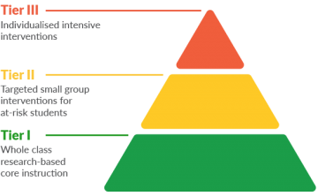
Individualised intensive interventions
Targeted short term interventions for at risk students
Whole school approaches

The Whole School Approach to Behaviour at Bibra Lake PS ensures that all students have
access to effective supports and systems that draw on their strengths and meet their needs.
This tiered approach forms a continuum of supports for staff and students and is informed by
quality systems for the collection of data and monitoring of data.

Tier 1 represents the practices and systems that are consistent over the whole school.
Approaches at this tier are proactive and preventative and targeted at all students and settings.

Tier 2 represents the behavioural responses and systems for students at risk. The approach at
this tier are more targeted, focusing on a proactive rapid short term response in a regular small group setting, (See page 10 for further information).

Tier 3 is representative of those students who require an intensive wrap around approach to
behaviour support. Quality data collection identifies that a student at this tier is non-responsive to
tier 1 and 2 interventions. Intervention is intensive and case managed through the Deputy Principal (SAER) and in collaboration with external stakeholders. (See page 11 for more information).

Tier 1 – A Positive Whole School Approach

Creating a Positive School Culture
The following initiatives/ programs are in place to achieve a positive and supportive learning
environment

- Student Wellbeing Officer
- School Psychologist
- Wellbeing Committee
- Targeted Literacy and Numeracy Intervention programs
- Friendly Schools Plus program
- SDERA Challenges and Choices program
- Whole school/ small group Zones of Regulation Program
- Restorative Practice
- BeYou Program
- Trauma Informed Practice
- Maker Club / Drawing Club / Origami Club / Sports Clubs and an open Library
- Student Leaders
- School Assemblies including special days (eg: ANZAC, Harmony Day etc…)
- Choir and Music productions
- Recognition of parent and volunteer help
- Interschool sporting events
- Golden Leaf Award (Sustainability/School Values)
- Golden Flute Award (School Song)
- Funky Fun Friday Skate Park visits

Positive Student Incentives

Whole School
School level incentives include:

- Merit certificates
- Values certificates
- Jump Jam Star Award
- Awards for outstanding achievement eg. Australian Mathematics
- Specialist awards
- Home reading certificates
- Assembly recognition of achievements outside of school
- Visit to administration staff with good work
- Principal’s lunch each term
- End of year” whole school reward”
- Good Standing Rewards (Week 5 and Week 10)
- Golden Leaf Award (Sustainability/School Values)
- Golden Flute Award (School Song)
- Funky Fun Friday tickets

Classroom
Positive incentives vary from class to class. Below is a list (non-exhaustive) of some of the positive
reinforcement that may be used within a class:
- Intrinsic rewards including praise and encouragement
- Extrinsic rewards:

  - Stickers
  - Stamps/Punch Cards
  - Class dojo points
  - Group points
  - Extra Outdoor Play
  - Funky Fun Friday Tickets
  - Week 5 and 10 Good Standing Class Rewards
  - Class party
  - Class incursions/excursions
  - Person of the Day

Code of Conduct
- We treat each other with kindness and respect
- We always follow all the school staff’s directions
- We consider the safety and well-being of all school staff, students and all members of the local community
- We respect other people and their property
- We care for our school environment and respect all school property
- We eat and play safely in the correct areas
- We remain on the school grounds
- Once we arrive at school for the day, we do not leave the school grounds.
- We do not bring toys, weapons or illegal substances onto the school property
- If it is necessary to bring a mobile phone to school, a Mobile Phone contract is completed by students and carers. The mobile phone is signed in to the front office daily.
- Smart watches are to be handed into the office daily from 8.30am – 3.00pm. Only digital/analogy watches are to be worn during the day.

Rights and Responsibilities
Students have the right to:  - Learn and make progress at their own pace without disruption;  - Be safe and happy at school and have their property respected;  - Be treated with kindness, sensitivity, respect and dignity;  - The safety of and respect for their property; and  - Contribute to a safe environment at school. | Students have the responsibility to:  - Work and allow others to work without disruption;  - Follow adults’ instructions and obey rules without backchat;  - Care for and respect others’, their own and school property; and  - Be kind, honest and respectful to others.
All Staff have the right to:  - Be happy and safe at school;  - Teach without disruption;  - Be treated with honesty, respect and dignity; and  - The safety of and respect for their property. | All Staff have the responsibility to:  - Teach/support students at the point of their individual need, enabling them to make progress and achieve success;  - Provide students with a relevant curriculum;  - Inform parents/guardians of their child’s progress;  - Provide a positive, caring and safe learning environment; and  - Treat others with honesty, respect and dignity.

Parents have the right to:  - Be informed about curriculum material, behaviour management procedures and decisions, and those affecting their child’s health and wellbeing;  - Be informed of their child’s progress; and  - Be heard on matters related to their child’s education. | Parents have the responsibility to:  - Ensure that their child is punctual and attends school;  - Ensure that the physical and emotional health and wellbeing of their child is at an optimum level, for effective learning;  - Ensure that the school is informed of issues of health and wellbeing;  - Ensure that their child is provided with appropriate food and equipment, ensuring effective learning;  - Support the school in providing a meaningful and optimum education for their children; and  - Acknowledge that the school has the responsibility to manage day-to-day issues that may arise between children during the school day.
Admin have the right to:  - Expect support from the teachers; and  - Be treated with respect, dignity and honesty. | Admin have the responsibility to:  - Be consistent within the guidelines of Education Department & Bibra Lake Policy; and  - Ensure teachers feel supported with decisions made when following behaviour management processes.

Social Emotional Learning (SEL) Curriculum
Bibra Lake Primary recognises that wellbeing and good mental health effect outcomes for students across all areas of schooling and effect the whole child. We recognise the importance of working alongside parents/carers in supporting and in some cases developing wellbeing and good mental health.

In order to develop students with good mental health we want to develop in our students a strong sense of self, the ability to self-regulate and connect with others and the resilience to bounce back after a real or perceived set back. We want students to leave Bibra Lake with the ability to make positive choices when faced with challenges and to be able to reach out to others.

Zones of Regulation K – 6
This program focuses on identifying and naming emotions and specifically targets the ability to self-regulate by introducing strategies and activities which lead young students to self-assess their state of being and provides a variety of activities to help in appropriate expression of emotions, centering and regulation of emotions.

As identifying, naming and regulating our emotions are at the root of wellbeing, Zones of Regulation will be the core focus for addressing SEL in the early years. The knowledge and practices that are developed during this phase will be refreshed in subsequent phases of learning and utilised as necessary with groups and individuals.

Friendly Schools Plus K – 3
Friendly Schools Plus will build on the Zones of Regulation through social emotional learning to strengthen well-being and addresses bullying prevention. It targets bullying prevention and becoming a 'Friendly School', as well as covering 5 Key Areas for social and emotional learning for students, at a developmentally appropriate level for each year level. These 5 Key Areas are: self-awareness, self-management, social awareness relationship skills and social decision-making.

SDERA Challenges and Choices 4 – 6
In years 4 – 6 the SEL will build on knowledge and understanding of the language of emotions, self-regulation and prosocial behaviours to bring their social emotional learning to bear on resilience and choices. The Resilience Modules from the SDERA Challenges and Choices program involve explicit teaching of personal and social capabilities that foster resilience and wellbeing among Year 4/5/6 students. The skills and attitudes to be explicitly taught are listed under four elements: self-awareness, self-management, social awareness, and social management.

Restorative practice
Restorative Practice is a process that helps students to understand the perspective of others and heal relationships through meaningful accountability. Restorative Practice is a whole school approach for encouraging behaviour that is pro-social and respectful. It encourages students to take ownership for their actions and repair any harm caused as a result of those actions. The approach focuses on building, maintaining, and restoring relationships in response to conflict. Each student models active listening skills and mutual respect, while the perspectives of each of the students is heard. The process facilitates students coming to a timely solution for ‘how to make things right’.

School staff may mediate the restorative process using the following 5 questions:
- What happened?
- What were you thinking at the time?
- What have you thought about since?
- Who has been harmed/ affected?
- What do you think you need to do to make things right?

*The process is most powerful when conducted in the classroom context.

Behaviour Management Procedures

Classroom Procedures for Years K-6
Staff will adopt a consistent sequential approach (see page 13) when dealing with negative classroom behaviour. It will be removed from emotion and managed as consequences the child has chosen through their actions.

Use of a Behaviour Management tracking sheet/chart is consistent in all classrooms and specialist classes. Students who display unacceptable behaviour will have their name moved down the chart. Students who make consistent effort to improve their behaviour can have their names moved back up the chart.

Step 1: Rule Reminder/Verbal Warning
Referral to class rules (worked out with class, stated simply). The child must be told what the warning is about. Younger children (K to Yr. 3) may have 2 warnings. The child’s name is recorded on a tracking sheet.

Step 2: Stop and Think
Reminder of the rule/acceptable behaviour. The child’s name is recorded on a tracking sheet.

Step 3: In class isolation – time in minutes is equal to the child’s age. (This is a guide. Time is at teacher’s discretion.)
The student will be placed in a space in the room (or area) where they take time to reflect upon their action/s. They continue with their work. There is no interaction with the student. Please set a timer. If, for whatever reason, there is interaction with the child, the timer is stopped. Time continues when the teacher deems the child is ready to continue with time out. Record on tracking sheet.

Step 4: Reflection Class
Work is to be continued for a minimum of 20 minutes in the child’s reflection class. The teacher needs to make time when the student has returned to class, to discuss events of the day and how they can make better choices next time. The teacher also needs to make time with the parent if this consequence is being used often. Record on tracking sheet.

At this point the minor offence needs to be entered into Compass to assist administration with any future parent/carer conversations.

Step 5: Time out – office
Administration will read details from the blue form filled out by the teacher and presented by the offending student. The offending student must be accompanied by another student.

For repeated or serious breaches, the administration will implement in-school withdrawal. Record on tracking sheet. Parents will be informed, and administration will record the incident on Compass.

Suspension
For severe incidents, red card to the office – end of line management procedure – to be used at the discretion of the school principal. Parents will be notified by administration.

The blue form must be completed that explains the red card behavior.

Please note:
- Teachers must use a visual representation of the 5 step “Classroom Behaviour Management System”.
- Specialist teachers must be informed of where a child’s place is on the BM process (if on in class isolation or above). This can be done verbally or with a note from the teachers.
- For severe behaviours (see page 9), students should be moved to step 5 immediately.
- Clean slate for all students the following day.

Playground Procedures
While within the School Rules, the following specific rules apply in the playground:
- Do not bring toys & sport equipment from home; and
- All food is to be eaten in designated areas
  - Recess outside classrooms
  - Lunch – Yrs 1-3 in undercover area
Yrs 4-6 under pergola

Students can be dismissed after cleaning up their area.
- Only small balls (eg tennis balls) are to be used in the undercover area
- All other balls on the oval/basketball court as appropriate
- No hat – No play in the sun for all four terms of the school year.
- No running on paths/paved areas around buildings. Please sit the child down on the spot if they are running.
- Years 1-3 on Northern end of oval, Yrs 4-6 on southern end of oval.

Duty Teacher
It is very important for Duty Teachers and Education Assistants to be continually moving around and observing whilst on duty. If you are aware of a negative incident, it is also important to intervene immediately and thoroughly investigate the issue or problem. Please do not ignore or take the situation lightly. Act to the severity of the problem. For example, it might mean separating children, having them sit out for 5 + minutes or with severe behaviours, call for administration.

The administration will determine whether the student receives an office withdrawal for the rest of lunch or the following day/s.

Please note:
- Playground incidents are to be entered by the teacher or education assistant.

Severe Behaviours
The principal may suspend a student from attendance at school as part of the school’s behaviour support plan. Suspension may be for the whole or part of each day during the suspension period.
Suspension is used when the breach of school discipline causes significant disruption to the student, other students, teachers or support staff, and is for the purpose of providing an opportunity:
- For the student, other students and staff to calm and recover; and/or
- For all to reflect on and learn from the incident, including where appropriate participating in restorative processes; and/or
- For the school to evaluate existing behaviour support plans, meet with any internal or external stakeholders, seek advice on how better to support the student, and put in place any adjustments to plans, resources, staff or strategies that may be required; and/or
- For the parent to meet with the school to discuss how to improve coordination between school and home to help the student behave appropriately at school.

Suspension is used also when the safety and physical/psychological well-being of school staff, students and other members of the school community have been breached.

The following categories are provided to facilitate state-wide consistency in systemic reporting.

Category 1: Physical aggression toward staff
Aggressive physical contact was committed intentionally against staff.
Category 2: Abuse, threats, harassment or intimidation of staff
Verbal or non-verbal actions that are abusive, harassing, intimidating or threatening, including stalking, sexual harassment, sexual innuendo and manipulation.
Category 3: Physical aggression towards students
Aggressive physical contact committed intentionally against another student
Category 4: Abuse, threats, harassment or intimidation of students
Verbal or non-verbal actions that is abusive, harassing, intimidating or threatening, including stalking, sexual harassment and innuendos.
Category 5: Damage to or theft of property
Direct or indirect damage to, or theft of, property.
Category 6: Violation of Code of Conduct or school/classroom rules
This covers student misconduct not addressed in any of the other categories that violate the school’s Code of Conduct.
Category 7: Possession, use or supply of substances with restricted sale
This category covers use or supply of substances such as cigarettes, e-cigarettes, vapes, alcohol and prescribed medicines, that are not in themselves illegal, but the sale of which may be restricted to persons over 18.
Category 8: Possession, use or supply of illegal substance(s) or objects
The substances referred to in this category are those that are illegal under the Criminal Code. This includes weapons and illegal drugs.
Category 9: E-breaches
Breaches under the Students Online policy or Personal Use of Mobile Electronic Devices requirements. Include breaches of an Acceptable Use Agreement; Appropriate Use of Online Services Agreement; and recording, distributing, or uploading of inappropriate images or messages of students, parents or staff with reasonable nexus to the school.
Category 10: Mobile Phones/Smart watches
This category covers inappropriate use of a mobile phone and/or smart watches. Uses include sexting or taking photos/recording.

Tier 2 – Targeted Intervention

Tier 2 interventions are those that are more targeted in response. Students who are not responding
to Tier 1 whole school approaches, access a specialised approach that focuses on rapid, early intervention.

At Bibra Lake, students have access to a range of small group targeted interventions providing skill development and positive behaviour support.

These include:
Lunch Time Clubs
Lunch Time Clubs are an initiative to help students interact with their peers in traditionally unstructured times of the school day. These staff organised options have been implemented to support students who are struggling to socialise with peers in the school setting.

Social Skills Programs
Social skills programs are initiated at point of need and cohort based. These sessions are designed
to develop a student’s personal and social capabilities. These may include: Emerging Youth, GRIT etc.

Student Wellbeing Officer
The student wellbeing officer offers pastoral care for our students. Classroom teachers can refer to the student services team if they believe a student might benefit from accessing the student wellbeing officer or a mentor.

Other strategies may include approaches such as check-ins, short term small group support or short-term IBP’s.

Tier 3 – Individualised Intensive Intervention

A ‘Student at Educational Risk’ is any student whose academic, behaviour, social and/or emotional attributes are a barrier to engagement with the content and standards defined in the Western Australian Curriculum. (Department of Education SAER Policy 1 January 2015)

Where a student presents with persistent and complex behaviours and is not responsive to whole school and targeted behavioural intervention processes, a referral is made to the Deputy Principal (SAER). Bibra Lake currently uses a range of individualised educational planning documents.

Case Management (Behaviour)
Our student-centred approach to building student capacity, extends to a case management approach where we place our students firmly in the centre of a network of support from family and relevant stakeholders including the classroom teacher, deputy principal, school psychologist, school of special educational needs- behaviour and engagement (SSENBE), disability (SSEND), medical and mental health (SSEN: MMH) and other external agencies as required.

Through planning meetings and case conferences, students’ complex needs are supported. We use a collaborative process where the needs of the child are identified, and a set of actions agreed upon. This wrap around approach incorporates intensive levels of support, and highly individualised plans that are reviewed regularly by all relevant stakeholders.

Referrals to the Deputy Principal (SAER) may include students with disabilities that display behaviour difficulties, social and emotional challenges, and mental health concerns. Students have access to a wide range of supports including the Student Wellbeing Officer and School Psychologist.

Students at Educational Risk
Students with disabilities are closely case managed by the Deputy Principal (SAER). Supplementary supports are put in place depending on individual student need and may include Special Needs Education Assistant (SNEA) supported break times and access to targeted interventions.

To ensure that high expectations of behaviour are maintained by all students, when required,
assistance from School of Special Education Needs Disability and/or Behaviour & Engagement (SSEN D and/or B&E) and relevant service providers will be sought to guide in the planning and
additional support for students.

Behaviour Management Plans
Behaviour Management Plans are designed to support a student whose behaviour continues to pose a challenge and has become increasingly complex, requiring a greater level of intervention and monitoring by the school. Typically, a Behaviour Management Plan will be part of a much bigger plan of action to support the student’s behaviour.
- A Behaviour Profile may be compiled detailing the student’s behaviours, and strategies for supporting pro-social behaviour. Observations may be captured using behaviour frequency data or functional behaviour analysis documents.
- Where applicable, key stakeholders work together with the classroom teacher to explore the function of the behaviour and build strategies to improve behaviour (alternative programs or timetables, or highly favourable incentives).
- Following this, a Behaviour Management Plan will be developed. If required, a Risk Management Plan will be included.

Regaining Good Standing
A student at educational risk receiving Individualised intensive Intervention (Tier 3) has the opportunity to regain their Good Standing by completing a positive behaviour plan that has been developed with the student, the classroom teacher and the Deputy Principal.

Suicidal Ideation and Non-Suicidal Self Injury (NSSI)
At Bibra Lake, we are proactive in promoting positive mental health and wellbeing and help seeking behaviour. We use complementary and preventative whole school programs such as Protective Behaviours, Zones of Regulation, Friendly Schools and SDERA to maximise the social and emotional outcomes of our students.

If a student presents with mental health concerns or reports/indicates NSSI, an intensive holistic approach is enlisted to provide effective, efficient and collaborated support for the student and their family.

Members of the leadership team have undertaken the Gatekeeper Suicide Prevention Training and Youth Mental Health First Aid and have the knowledge and skills to provide support for the students in need. Nominated staff members have links with the School Psychologist/Lead School Psychologists and/or other professionals trained in suicide risk assessment for consultation and referral where required.

This assists the school to build their capacity with prevention, preparedness, response and recovery when supporting students with suicidal ideation and NSSI.

Schools play a critical role in supporting a student in their recovery following disclosure of suicidal ideation or NSSI. In accordance with the Department of Education’s school response and planning guidelines for students with suicidal behaviour and NSSI, we follow the response flow chart to ensure a comprehensive, rational and child-centred approach is taken to support the student and their families, with immediate risk and safety of the child at the forefront of any informed decision making.

Key Points followed from the response flow chart:
- If there has been a direct or indirect disclosure the Principal, Deputy Principals or nominated staff member is informed immediately once the student is kept safe;
- A Risk Management Plan is followed if the child has an established plan. Parent/guardian is contacted and notified of concerns for the student. The importance of a supportive response to their child’s disclosure is emphasised to parents;
- A risk assessment by a trained staff member may take place. The child may be referred to an external assessment when a trained staff member is not available or further risks are identified for the child. Students are advised of limits of confidently, with the students aware that only the necessary information in relation to the risk may be shared with appropriate family members and school personnel’s as part of planning support; and
- The school considers the implementation or revision of a Risk Management Plan for the student in need and their families for further planning and on-going support.

APPENDIX A – Behaviour Management Process Chart

Well done
First Warning
Stop and Think
In Class Isolation
Reflection Class
Time Out - Office

BLPS Behaviour Management Process

APPENDIX B – BEHAVIOR MANAGEMENT CLASSROOM TRACKER
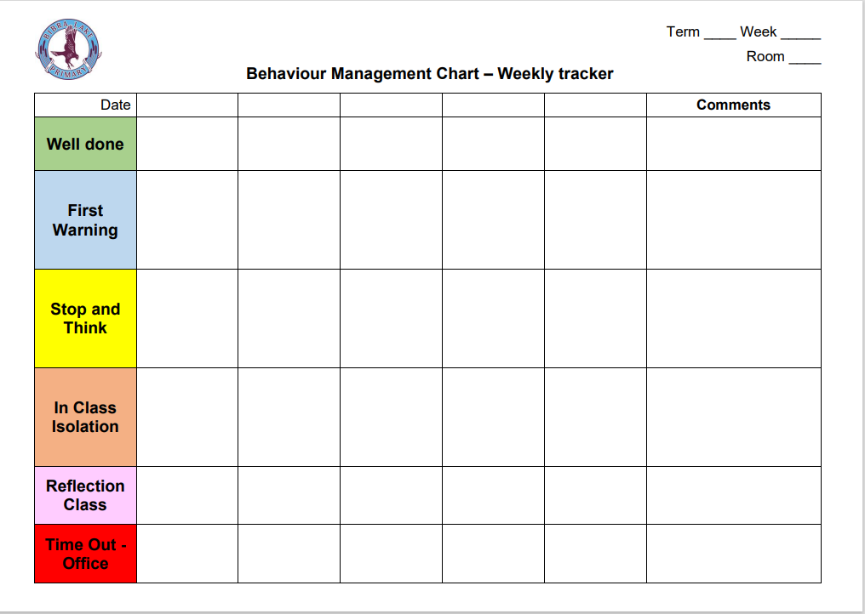

APPENDIX C – GOOD STANDING POLICY

At Bibra Lake Primary School, the Good Standing Policy supports our values of Respect, Responsibility, Learning and Connection and acknowledges exemplary behaviour, work ethic, and attendance. We believe that learning is enhanced in a welcoming, inclusive, collaborative and caring environment, free from disruption and any form of violence. The Good Standing Policy emphasises the importance of students taking responsibility for the choices that they make on a daily basis, which impacts academically and socially on themselves and others.

The Good Standing Policy is provided to maintain consistency in our decision-making processes. It is important to note that these are guidelines and the following factors will be taken into account before a decision to withdraw or maintain a student’s ‘Good Standing’ is made:
- If there are extenuating circumstances that have resulted in the negative behaviours;
- If a student has a documented plan; and/or
- If there is a significant period of positive behaviour since the previous negative behaviour.

To maintain ‘Good Standing’, students must:
- Comply with the Bibra Lake Primary School’s ‘Code of Conduct’; and
- Follow the Bibra Lake Primary School’s Whole School Approach to Behaviour and classroom behaviour management procedures.

‘Good Standing’ is a status all Bibra Lake Primary School students are granted at the start of each five week block.
- It is the responsibility of each student to maintain their ‘Good Standing’.
- Students with ‘Good Standing’ are eligible to participate in extracurricular activities.
- Students who lose their ‘Good Standing’ may lose the privilege to participate in various events throughout the school year. Example: Rewards Day.

Students who maintain “Good Standing’ will be eligible to take part in whole class rewards in Week 5 and Week 10 of each term. An example of a Week 5 reward could be an extra 20 mins of Recess or Lunch time. These rewards can be organised between teachers at a class, block of year group level.

Parents and Carers of students ‘at risk’ of losing their Good Standing will be contacted by teachers or the Administration team. This will be through a phone call or email and then on loss of Good Standing formally via email.

A student’s ‘Good Standing’ status will be withdrawn following consultation with the Administration and the classroom teacher for the following reasons:
- Three strikes for Year 6 students given at the discretion of their classroom teacher. This must be entered on Compass by the classroom teacher with the parents notified.
- Three referrals for classroom referrals to Administration. This must be entered on Compass by the classroom teacher or Administration with the parents notified.
- Three recorded referrals for playground referrals which have been entered on Compass by the teacher or Administration. (Sometimes the duty teacher.)
- Suspension. Entered by Administration.
- If a student leader loses their ‘Good Standing’, they will lose their right to represent the school for a five-week period.
- For Tier 3 students ‘Good Standing’ will be assessed on a case-by-case basis.

Severe Clause
- Students may lose the privilege to participate in activities where the safety of other students is a concern.
- Students who are involved in a ‘one off’ severe behaviour incident in the classroom or playground may automatically lose their ‘Good Standing’.

Regaining ‘Good Standing’
- All students will regain ‘Good Standing’ at the beginning of each 5 week period.
- All students have one opportunity to regain ‘Good Standing’ in a 5 week period. This would be via a regaining ‘Good Standing Contract’ negotiated and recorded by the classroom teacher and communicated to parents.
- Students receiving Individualised Intensive intervention (Tier 3) will have two opportunities in a five-week period to regain their ‘Good Standing’. This contract will be negotiated with the student and classroom teacher in consultation with parents by Administration on a case-by-case basis.

Tracking Good Standing
- For Tier 1 and Tier 2 students this will be recorded on the Regaining Good Standing Contract tracking sheet available at S:\AdminShared\All Staff\Behaviour to be filled in by the classroom teacher.
- A copy of the contract is forwarded to Administration and parents.
- Tier 3 students will be monitored by Administration and be recorded on the Tier 3 Tracking Sheet available at S:\AdminShared\All Staff\Behaviour.

APPENDIX D – REGAINING GOOD STANDING CONTRACTS
