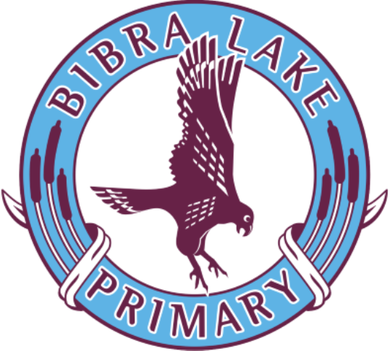
Bibra Lake Primary School Uniform Policy

Latest UpdateD: September 2025
2025
Introduction
The School Board of Bibra Lake Primary School has established a dress code for all students attending the School.

The School Board believes a school dress code:
- Fosters and enhances the public image of the school;
- Assists in building school and team spirit;
- Ensures students are safely dressed for specific school activities;
- Encourages equity among students; and
- Prepares students for work, as many work places have dress and safety codes.

Advice to Students on the Dress Code
Students should ensure that they use appropriate protection from the sun when outdoors. Hats are to be worn at all times for outdoor activities throughout the year. Bibra Lake Primary has a no hat play in the shade policy.

Availability of Dress Code Items
- A uniform shop operates at our school and items may be ordered on the School Uniform order form or via the flexi school app. Items in the designated school colours may also be purchased from any clothing or department store if desired, however items are to be plain with no logo/slogans/patterns/striping etc. Winter jumpers are to be plain maroon and NO hoodies are allowed.

- Sports uniforms and tracksuits may be ordered through the school. Sports uniform will be required for participation in Interschool Sport. For some Interschool and specialised sports events, the school will supply a sports polo.

Modifications to the Dress Code
Students who, for religious or health reasons, may wish to modify the school dress code are required to make an appointment with the principal or designated staff member. Staff will be informed of any student granted a modification to the dress code.

Students not following the dress code will receive:
- Counselling from a designated staff member on the benefits of a dress code;
- Assistance/support in obtaining suitable clothing, if necessary; and
- A pass for an agreed length of time for dress modification.

Students not following the dress code may be denied the opportunity to represent their school at official school activities, which include choir, sporting and social event

School Uniform Shop Information
The Uniform Shop operates next to EC4 and orders can be placed online via the Flexi Schools App. Orders must be placed by 1pm on Tuesdays to be processed and delivered that day. Please be aware orders are only filled and delivered on the Tuesdays set out in the Term Planner.

For all enquires please contact the Uniform Co-ordinator Uniformshopblps@gmail.com

Flexi schools for the Uniform Shop
Flexi Schools is an online ordering system to make it easy for parents who want to use a card instead of cash.
Online ordering is available

Easy as 1,2,3....
1. Download the flexi school’s app
2. Set up your account
3. Add Bibra Lake Primary School and your child(ren)

Lost Clothing
The P & C Association maintains a lost clothing cupboard (for unnamed items) outside the Canteen. Please mark all clothing with your child’s name so it can easily be returned to you.

Footwear
Appropriate footwear is necessary (no thongs, sandals or Ugg boots)

Jewellery
Jewellery or valuables are not to be worn or brought to school, except for small studs or sleepers, watches or medic alert bracelets.

Other
Makeup including nail polish and acrylic nails is not permitted. Hair colouring is not permitted (unless on special occasions). Hair longer than shoulder length (girls and boys) must be tied back.

Bibra Lake Primary School Dress Code Selection
SEASON | BOYS | GIRLS
SUMMER | - Short sleeve light blue polo  - Kindy/Pre-Primary t-shirt Year 6  - Leavers polo  - Faction polo  - Black shorts *  - Bibra Lake surf or bucket hat | - Short sleeve light blue polo  - Kindy/Pre-Primary t-shirt  - Year 6 Leavers polo  - Faction polo  - Black shorts or skort *  - Bibra Lake PS check dress  - Bibra Lake surf or bucket hat
WINTER | - Short sleeve light blue polo  - Long sleeve light blue polo  - Kindy/Pre-Primary t-shirt  - Year 6 Leavers t-shirt  - Faction polo  - Black shorts *  - Plain black track pants  - Maroon polar fleece  - Maroon V neck pullover  - Maroon zip jacket  - Year 6 Leavers jacket  - Bibra Lake surf or bucket hat | - Short sleeve light blue polo  - Long sleeve light blue polo  - Kindy/Pre-Primary t-shirt  - Year 6 Leavers t-shirt  - Faction Polo  - Black shorts or skort *  - Bibra Lake PS check dress  - Plain black track/dance pants  - Maroon polar fleece  - Maroon V neck pullover  - Maroon zip jacket  - Year 6 Leavers jacket  - Bibra Lake surf or bucket hat
SPORT | - Faction polo  - Light blue polo  - Black shorts *  - Bibra Lake surf or bucket hat | - Faction polo  - Light blue polo  - Black shorts/skort *  - Bibra Lake surf or bucket hat
INTERSCHOOL SPORT | - Light blue polo  - Interschool polo (supplied by school)  - Black shorts *  - Bibra Lake surf or bucket hat | - Light blue polo  - Interschool polo (supplied by school)  - Black shorts/skort *  - Bibra Lake surf or bucket hat

* Shorts and skorts must be no shorter than mid-thigh

